Modernizing a 100K+ ESLOC Fortran Codebase: Methodology, Complexity, and Cost Drivers
For a Fortran application exceeding 100,000 estimated source lines of code (ESLOC), particularly one supporting RADAR processing, weapon-system simulation, signal processing, or high-performance computing (HPC), I recommend an incremental modernization strategy based on software characterization, automated analysis, behavioral testing, and progressive architectural refactoring.
The most important principle is:
Do not start by rewriting the Fortran code. Start by determining what the code does, how it behaves, what it depends on, and what must remain mathematically equivalent.
A mature Fortran application may contain decades of validated algorithms and engineering knowledge. Rewriting it without understanding those assets can introduce subtle numerical errors, degrade performance, and invalidate previously established confidence in the software.
NASA's Jet Propulsion Laboratory has described an incremental modernization approach that preserves existing Fortran routines while adding modern interfaces and capabilities. NASA's experience modernizing its Chemical Equilibrium with Applications software also illustrates how legacy Fortran can evolve into a modern, modular application without abandoning its established computational foundation. (NASA Technical Reports Server)
Below is a methodology you can use to assess a 100K+ ESLOC codebase, estimate difficulty, and develop a modernization plan.

1. Recommended Modernization Strategy
I would divide the effort into six phases.
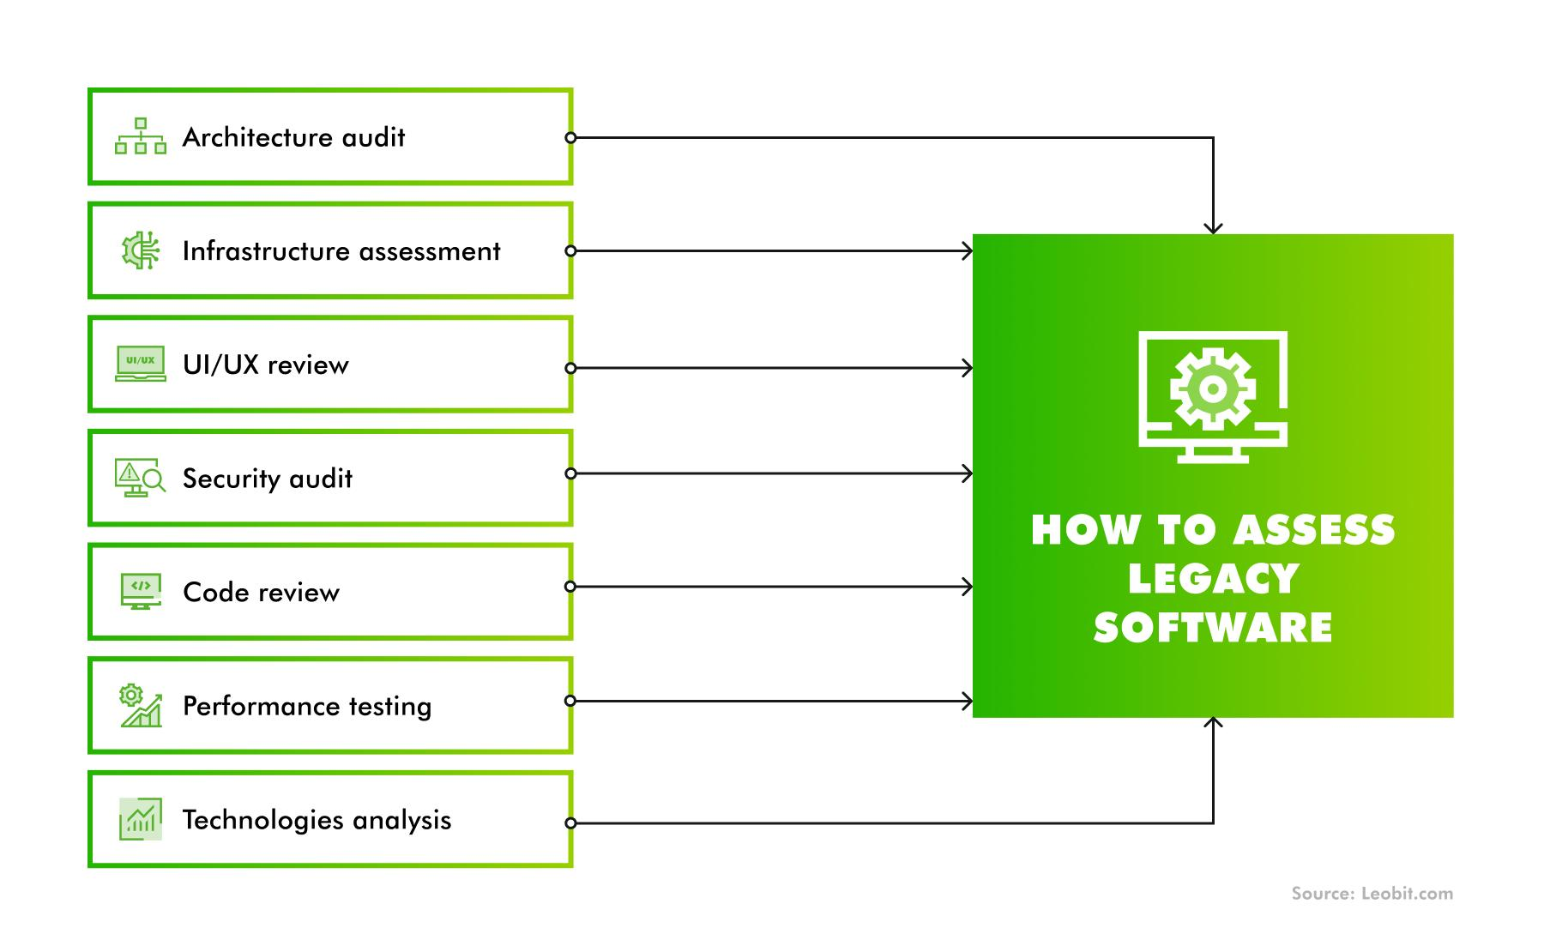
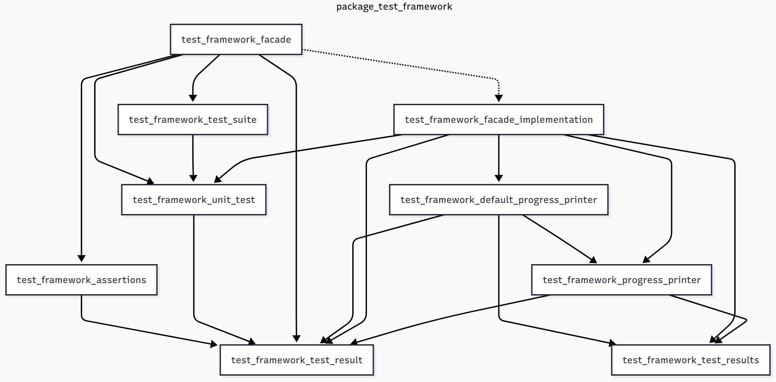
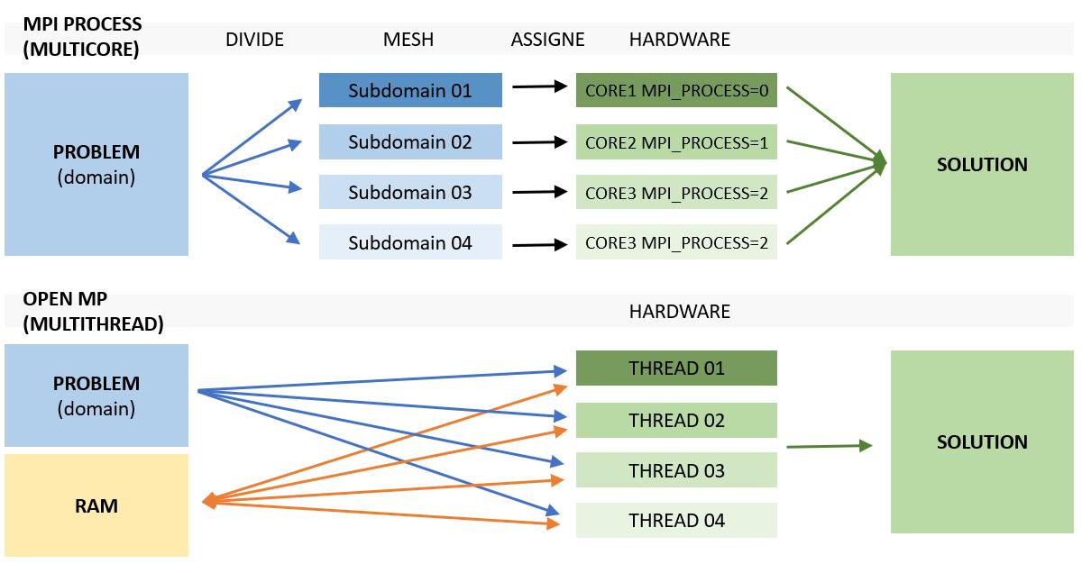
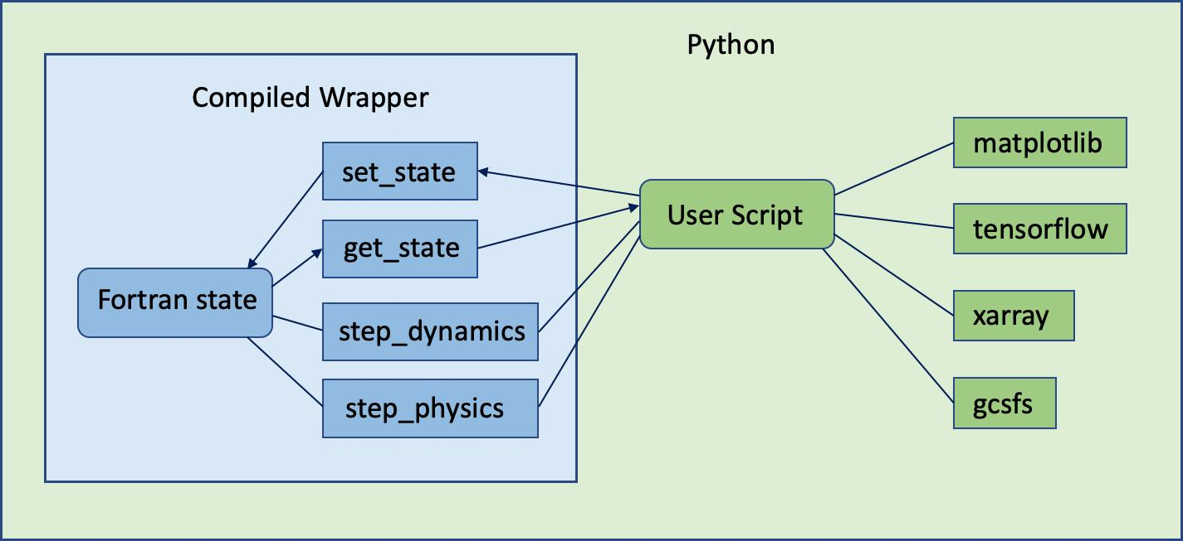
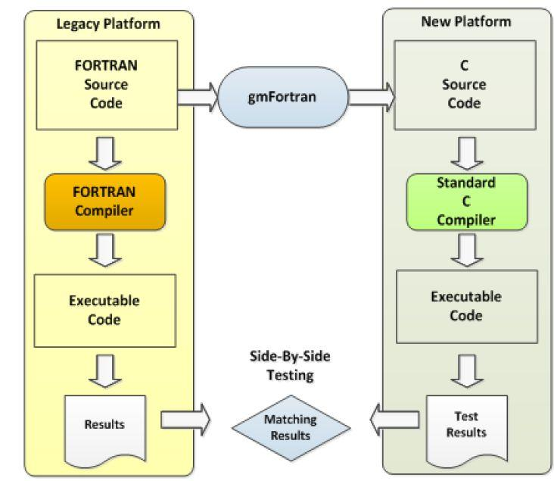
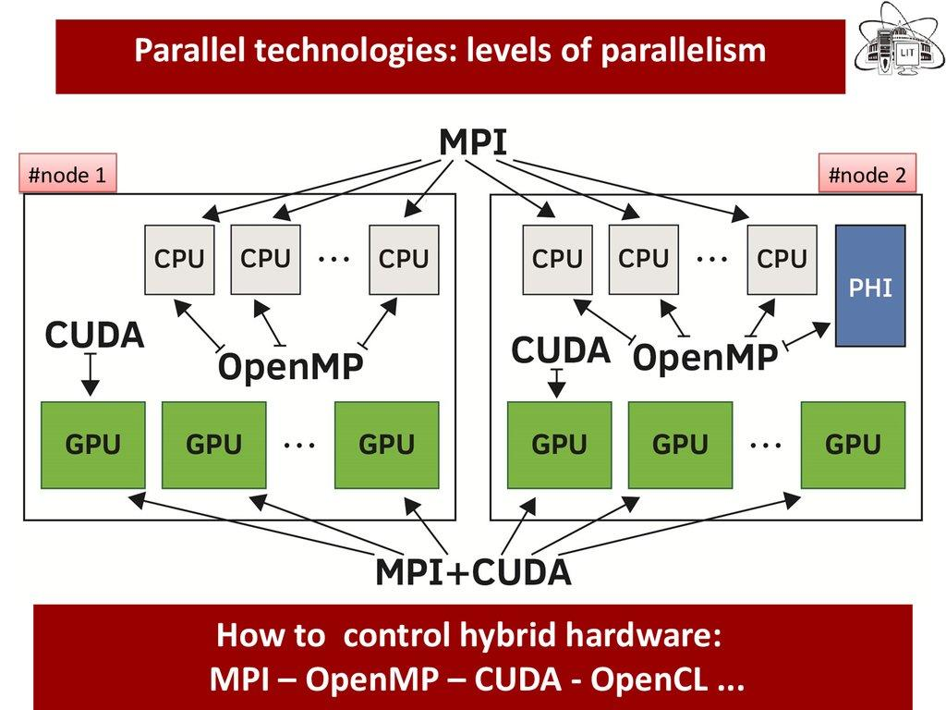
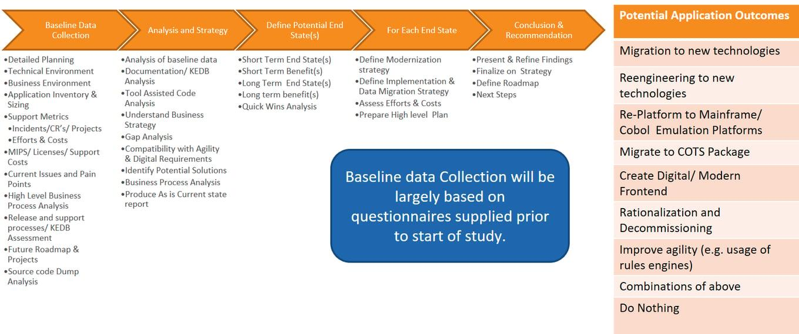
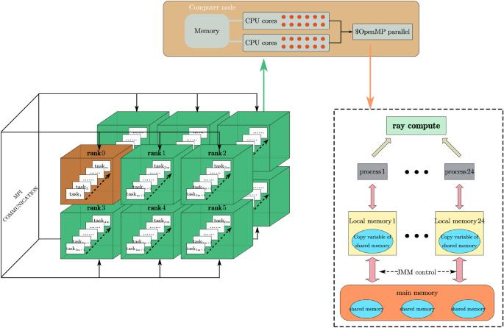
Phase | Activity | Primary objective | Deliverable
1 | Codebase discovery | Understand the software and its dependencies | Software inventory and baseline
2 | Complexity assessment | Determine technical difficulty and modernization risk | Complexity score and risk register
3 | Behavioral characterization | Establish what the existing application actually does | Baseline test suite and reference outputs
4 | Incremental modernization | Refactor code and introduce modern interfaces | Modernized modules and interfaces
5 | Performance and numerical validation | Demonstrate equivalent results and acceptable performance | Verification and validation evidence
6 | Operational transition | Deploy, document, and sustain the modernized application | Release package and sustainment plan
The phases overlap. For example, you should begin building tests during discovery rather than waiting for the entire assessment to finish.

Phase 1: Discover and inventory the codebase
Before estimating modernization costs, determine what constitutes the actual software system.
A 100K ESLOC application can be relatively straightforward if it consists of independent numerical routines. A smaller application can be much more difficult if it contains tightly coupled algorithms, distributed-memory parallelism, real-time interfaces, and undocumented hardware dependencies.

A. Inventory the source code
Collect the following information:
- Total physical lines of code.
- Estimated executable source lines of code (ESLOC).
- Lines by language and file type.
- Fortran version and dialects.
- Number of programs, modules, subroutines, and functions.
- Number of source files.
- Number and complexity of shared data structures.
- Number of external libraries and interfaces.
- Build system and compiler dependencies.
- Automated test coverage.
- Documentation and requirements availability.
- Historical defect and maintenance information.
For Fortran, pay particular attention to:
- COMMON blocks.
- EQUIVALENCE statements.
- Implicit typing.
- INCLUDE files.
- Global state.
- Fixed-form source.
- Compiler-specific extensions.
- Unformatted binary files.
- External procedures with implicit interfaces.
- GOTO-based control flow.
- Shared mutable arrays.
- Handwritten numerical algorithms.
These features are not automatically defects. However, they can make data flow, program behavior, and safe refactoring more difficult to establish.

B. Map the architecture
Build a dependency graph identifying which routines call other routines and which modules share data.
For example, a RADAR processing application might have this architecture:
RADAR DATA INPUT
|
v
Signal Conditioning
|
v
Digital Filtering
|
v
FFT / Signal Analysis
|
v
Detection Algorithms
|
v
Tracking Algorithms
|
v
Track Association
|
v
Mission-Level Outputs
This is an illustrative architecture, not a claim about the structure of your specific application.
For each component, identify:
- Inputs and outputs.
- Called routines.
- Shared data.
- Numerical assumptions.
- Execution frequency.
- Performance requirements.
- External dependencies.
- Available verification evidence.
The result should be a map of the software's functional and technical dependencies—not just a list of source files.

2. Establish a Complexity Model
I recommend separating complexity into two dimensions:
- Software modernization complexity: How difficult will the code be to understand, restructure, and maintain?
- Mission and computational complexity: How difficult will it be to demonstrate that the modernized software still produces correct results under realistic operating conditions?
These dimensions should be evaluated separately.
For example, a legacy RADAR algorithm might be structurally simple but extremely difficult to validate because small numerical differences can affect detection probability or false-alarm performance.
Conversely, a complex data-processing application might be relatively easy to modernize if it has well-defined interfaces and comprehensive regression tests.

2.1 Five modernization difficulty levels
The following classification is a proposed planning framework, not an established industry-wide rating standard.
Level | Classification | Typical characteristics | Relative difficulty
1 | Low | Modular Fortran, limited dependencies, well-understood algorithms | Low
2 | Moderate | Legacy procedural code, some global state, limited test coverage | Moderate
3 | High | Tightly coupled modules, complex numerical algorithms, undocumented behavior | High
4 | Very high | RADAR, sensor fusion, advanced simulation, substantial parallel computing | Very high
5 | Critical | Mission-critical algorithms, real-time constraints, complex HPC, safety or mission assurance requirements | Extreme
A codebase does not automatically belong at Level 4 or 5 just because it uses RADAR or HPC.
The rating depends on its actual implementation, requirements, interfaces, test evidence, and consequences of failure.

Level 1: Low complexity
Example: A 100K ESLOC scientific application that performs established mathematical calculations using mostly independent subroutines.
Characteristics:
- Limited global state.
- Well-defined inputs and outputs.
- Few external dependencies.
- Existing regression tests.
- No significant real-time constraints.
- Straightforward compilation and execution.
Recommended approach:
- Move related procedures into modules.
- Add explicit interfaces and stronger typing.
- Introduce automated builds and regression testing.
- Remove dead code after verifying it is unused.
- Add modern interfaces where necessary.
Fortran 2008 may be an appropriate modernization target, although the target standard should be selected based on compiler availability, dependencies, and project requirements.
Primary risk: Introducing unintended behavior while changing code that already works.

Level 2: Moderate complexity
Example: A legacy engineering application with many subroutines, shared variables, and incomplete documentation.
Characteristics:
- Significant use of COMMON blocks.
- Implicit interfaces.
- Shared global variables.
- Limited unit testing.
- Some compiler-specific behavior.
- Unclear ownership of individual modules.
Recommended approach:
- Establish baseline test cases.
- Document important data structures.
- Identify shared state and side effects.
- Introduce modules around logical groups of routines.
- Gradually replace global data with explicit interfaces.
- Apply static analysis and compiler diagnostics.
Primary risk: Hidden dependencies between routines.
For example, a subroutine may appear to calculate a result independently but actually depend on a global variable modified by a different routine earlier in the execution sequence.
That dependency must be understood before refactoring.

Level 3: High complexity
Example: A weapon-system simulation or engineering model with tightly coupled physics, numerical solvers, and external data interfaces.
Characteristics:
- Complex numerical algorithms.
- Extensive cross-module dependencies.
- Limited independent testing.
- Multiple compiler versions or platforms.
- Floating-point sensitivity.
- Large shared data structures.
- Significant undocumented engineering assumptions.
Recommended approach:
- Partition the application into functional subsystems.
- Establish numerical reference cases.
- Build tests around important computational routines.
- Modernize one subsystem at a time.
- Compare intermediate numerical results.
- Profile the application before changing computational algorithms.
- Preserve legacy interfaces until replacements are verified.
Primary risk: Producing results that look reasonable but are mathematically or operationally incorrect.
For scientific software, matching a few final output values is often insufficient. Validation may require comparisons of intermediate values, conservation properties, convergence behavior, numerical tolerances, and performance across representative operating conditions.

Level 4: Very high complexity
Example: An advanced RADAR processing application or HPC simulation involving complex signal processing, parallel computation, and multiple computational subsystems.
Characteristics may include:
- FFTs and specialized numerical libraries.
- Digital signal processing.
- Detection and tracking algorithms.
- Matrix operations and numerical solvers.
- MPI-based distributed computing.
- OpenMP multithreading.
- SIMD vectorization.
- GPU acceleration.
- Real-time or near-real-time performance requirements.
- Large data volumes.
- Platform-dependent numerical behavior.
Recommended approach:
- Separate algorithm modernization from architectural modernization.
- Profile computational hotspots before making optimization decisions.
- Establish deterministic or statistically characterized reference tests, as appropriate.
- Preserve the original computational implementation while modernizing surrounding interfaces.
- Measure scaling and throughput before and after changes.
- Validate single-threaded, multithreaded, and distributed execution separately.
- Introduce parallelism or GPU acceleration only where justified by requirements and profiling.
Primary risk: Preserving nominal functionality while degrading performance, numerical behavior, or parallel correctness.
Intel's code-modernization guidance emphasizes profiling first, then examining scalar performance, vectorization, threading, and distributed-memory parallelism. This is a useful sequence for HPC applications because architectural changes can otherwise make performance regressions difficult to isolate. (Intel)

Level 5: Critical complexity
Example: A mission-critical RADAR, sensor-fusion, or weapon-system application that combines complex algorithms, real-time constraints, specialized computing environments, and demanding verification requirements.
Characteristics may include:
- Safety- or mission-critical computations.
- Complex interactions between algorithms and hardware.
- Strict timing requirements.
- Extensive parallel execution.
- Legacy interfaces with external systems.
- Difficult-to-reproduce operational scenarios.
- Limited access to original developers or subject-matter experts.
- Formal verification, certification, or authorization obligations.
Recommended approach:
- Use a controlled, evidence-driven modernization program.
- Establish formal configuration management and change traceability.
- Retain the existing application as a reference implementation where feasible.
- Develop requirements-linked verification and validation evidence.
- Use independent technical reviews.
- Validate timing, numerical behavior, and operational failure modes.
- Require explicit acceptance criteria for each migrated subsystem.
- Introduce changes incrementally rather than replacing multiple critical subsystems simultaneously.
Primary risk: A modernization change introduces an undetected defect that affects a mission-relevant outcome.
For this level, the effort is often driven more by verification, validation, integration, and assurance than by the amount of code that must be rewritten.

3. RADAR, HPC, and Other Sophisticated Applications
The type of application significantly influences modernization difficulty.
The following table provides an initial planning estimate for a 100K ESLOC application. These are relative estimates, not empirically established industry averages.
Application type | Typical difficulty | Main drivers | Dominant validation concern
Engineering calculations | Level 1–2 | Data structures, numerical routines | Numerical equivalence
Scientific modeling | Level 2–3 | Solver complexity, mathematical dependencies | Accuracy and convergence
Monte Carlo simulation | Level 3 | Random-number generation, statistical behavior | Statistical equivalence
Image processing | Level 3–4 | Large arrays, numerical kernels, throughput | Image quality and numerical fidelity
RADAR signal processing | Level 4–5 | DSP, FFTs, detection, tracking, timing | Detection and tracking performance
Sensor fusion | Level 4–5 | State estimation, time synchronization, data association | Estimation accuracy and robustness
HPC simulation | Level 3–5 | MPI, OpenMP, memory bandwidth, scaling | Numerical correctness and scalability
Real-time embedded processing | Level 4–5 | Timing, hardware interfaces, memory constraints | Timing and operational behavior
Coupled RADAR/HPC application | Level 5 | Combined algorithmic, computational, and integration risks | End-to-end mission performance
These categories overlap. For example, a RADAR application running on an HPC cluster might require both statistical signal-processing validation and distributed-computing verification.

3.1 Why RADAR code is particularly difficult
RADAR processing often combines several different forms of computational complexity.
Signal processing
- Filtering.
- FFT processing.
- Pulse compression.
- Doppler processing.
- Beamforming.
- Windowing and interpolation.
Detection
- Thresholding.
- Detection probability.
- False-alarm probability.
- Clutter and noise modeling.
- Operating-point sensitivity.
Tracking
- Track initiation.
- Track maintenance.
- State estimation.
- Data association.
- Track termination.
Operational performance
- Latency.
- Throughput.
- Memory use.
- Processing deadlines.
- Behavior under degraded input conditions.
The modernization team must determine which outputs require numerical equivalence and which require functional or statistical equivalence.
For example, changing compiler optimization settings could produce slightly different floating-point results. That difference might be harmless for one intermediate calculation but important if it causes a detection decision to cross a threshold.
A suitable validation strategy might include:
- Comparing intermediate signal-processing outputs.
- Comparing detection and false-alarm statistics.
- Testing representative signal-to-noise conditions.
- Evaluating tracking accuracy across representative scenarios.
- Measuring end-to-end latency and throughput.
- Testing behavior under boundary and degraded conditions.
The required tests should be derived from the application's actual requirements and operational use cases, not assumed from the RADAR label alone.

3.2 Why HPC code is particularly difficult
HPC introduces a separate set of risks.
Technical area | Modernization challenge
MPI | Communication patterns, rank synchronization, collective operations
OpenMP | Thread safety, race conditions, synchronization
GPU computing | Device memory, host-device transfers, numerical differences
Vectorization | Alignment, memory layout, compiler optimization
Distributed memory | Data decomposition and communication overhead
Numerical solvers | Convergence and floating-point sensitivity
Parallel reductions | Different accumulation orders and rounding behavior
Performance scaling | Changes in runtime as processors or nodes increase
For example, a parallel reduction can sum floating-point values in a different order after modernization. Because floating-point addition is not perfectly associative, the result may differ slightly even if the algorithm is otherwise correct.
For HPC applications, therefore, the acceptance criteria must include both computational correctness and performance characteristics.

4. Choose the Right Modernization Method
Not every 100K ESLOC application should undergo the same degree of transformation.
I recommend evaluating four approaches.
Approach | What changes? | Relative risk | When to use
A. Stabilize and harden | Build system, tests, diagnostics, documentation | Lowest | Existing code is valuable and operational
B. Modernize Fortran incrementally | Modules, explicit interfaces, data structures, typing | Low–moderate | Fortran remains the right computational language
C. Wrap and integrate | Preserve Fortran kernels while adding modern APIs and interfaces | Moderate | New capabilities are needed without replacing validated algorithms
D. Rewrite selected subsystems | Replace specific routines or subsystems in another language | High | A specific subsystem has a compelling technical or operational reason to change
These approaches can be combined.

Approach A: Stabilize the existing code
This is the right starting point when the application lacks reliable automated tests or has poorly understood dependencies.
Actions:
- Establish a reproducible build.
- Document supported compilers and platforms.
- Add compiler warnings and runtime diagnostics.
- Capture reference outputs.
- Introduce automated regression tests.
- Identify dead code and high-risk routines.
- Establish version control and repeatable releases.
This phase may deliver substantial improvements without changing the core algorithms.

Approach B: Modernize within Fortran
For scientific and HPC applications, this is often the best long-term path.
Typical transformations include:
Legacy pattern | Modernization target
Implicit typing | implicit none and explicit declarations
COMMON blocks | Modules or explicitly managed data structures
Implicit procedure interfaces | Explicit interfaces and module procedures
Uncontrolled global state | Encapsulated state with defined ownership
Fixed-form source | Free-form source where appropriate
Manual memory management | Better-defined allocation and ownership practices
Monolithic procedures | Smaller, cohesive procedures with defined responsibilities
Compiler-specific assumptions | Portable, standards-based implementations where feasible
Modernization does not require converting every subroutine into object-oriented code.
Fortran modules, derived types, explicit interfaces, and carefully controlled data access can provide substantial improvements without imposing unnecessary architectural complexity.

Approach C: Wrap the Fortran application
This is especially attractive when validated numerical kernels must be preserved but the software needs new interfaces or capabilities.
For example:
Modern User Interface
|
v
Python / C / C++
|
v
Interoperability
Interface
|
v
Existing Fortran APIs
|
v
Fortran Kernels
/ \
v v
RADAR DSP Numerical Solvers
Potential benefits include:
- Python-based analysis and automation.
- Integration with modern data pipelines.
- Easier development of test harnesses.
- New visualization capabilities.
- Integration with simulation frameworks.
- Support for modern user interfaces.
The Fortran computational core remains intact until there is a demonstrated reason to replace it.
NASA's modernized CEA application illustrates this general direction: the computational software was modernized in Fortran 2008 while adding interfaces for other programming languages and engineering workflows. (NASA)

Approach D: Rewrite selected subsystems
I would not recommend translating an entire 100K ESLOC Fortran codebase into C++, Python, or Rust as the default strategy.
Instead, identify specific subsystems where replacement provides a measurable benefit.
Potential candidates include:
- User interfaces.
- Data ingestion.
- File conversion.
- Visualization.
- Workflow orchestration.
- Isolated algorithms with well-defined interfaces.
- Components that require capabilities unavailable in the existing implementation.
A rewrite becomes more attractive when a subsystem is difficult to maintain, has a stable interface, has sufficient reference tests, and offers a clear benefit from replacement.
The goal should be modernization of the software capability, not conversion of every line of source code.

5. Build a Quantitative Complexity and Risk Assessment
For a large codebase, I recommend creating a scoring model that can be applied consistently across multiple applications.
The following model is suitable for an initial technical assessment.
Score each dimension from 1 to 5:
- 1: Low complexity.
- 2: Limited complexity.
- 3: Moderate complexity.
- 4: High complexity.
- 5: Very high complexity.

Proposed assessment dimensions
Dimension | Weight | What to evaluate
Architectural coupling | 15% | Dependencies, global state, shared data
Algorithmic complexity | 15% | Mathematical complexity and domain-specific logic
Numerical sensitivity | 15% | Floating-point behavior, convergence, numerical tolerances
Parallelism and HPC | 15% | MPI, OpenMP, GPU execution, scalability
Testability and verification | 15% | Test coverage, reference outputs, validation evidence
External dependencies | 10% | Libraries, hardware, compilers, external interfaces
Documentation and requirements | 10% | Architecture, design, requirements, domain knowledge
Build and deployment complexity | 5% | Build reproducibility, platform support, deployment constraints
Total | 100%
The weights are proposed starting values. For a RADAR application, you might increase the weights assigned to algorithmic complexity, numerical sensitivity, and verification. For an HPC application, you might increase the weights for parallelism and numerical sensitivity.

Calculation
Calculate a weighted average:
$$C=\frac{\sum_{i=1}^{8}{w_{i}}s_{i}}{100}$$
Where:
- $C$= overall complexity score.
- $w_{i}$= dimension weight, expressed as a percentage.
- $s_{i}$= dimension score from 1 to 5.
Interpret the score as follows:
Score | Proposed category | Planning implication
1.00–1.79 | Low | Standard incremental modernization
1.80–2.59 | Moderate | Additional characterization and dependency analysis
2.60–3.39 | High | Subsystem-level migration with strong regression testing
3.40–4.19 | Very high | Dedicated technical workstreams and extensive validation
4.20–5.00 | Extreme | Mission-focused modernization with rigorous verification and transition controls
These thresholds are planning conventions, not validated predictive boundaries.

Example: 100K ESLOC RADAR application
Suppose the initial assessment produces the following scores.
Dimension | Weight | Score | Weighted contribution
Architectural coupling | 15% | 4 | 0.60
Algorithmic complexity | 15% | 5 | 0.75
Numerical sensitivity | 15% | 5 | 0.75
Parallelism and HPC | 15% | 4 | 0.60
Testability and verification | 15% | 4 | 0.60
External dependencies | 10% | 3 | 0.30
Documentation and requirements | 10% | 4 | 0.40
Build and deployment | 5% | 3 | 0.15
Total | 100% |  | 4.15
The score is 4.15 out of 5, placing this illustrative application in the very-high-complexity category.
That suggests a modernization program with separate workstreams for:
- Code analysis and architecture.
- Numerical algorithm characterization.
- Build and toolchain modernization.
- Incremental refactoring.
- Performance and parallel-computing validation.
- System-level verification and transition.
One caution: this score measures technical complexity, not project cost directly. A separate risk assessment should consider failure consequences, mission criticality, available expertise, and schedule constraints.

6. Estimate Effort for a 100K ESLOC Application
A useful planning exercise is to estimate the effort for each modernization phase rather than multiplying ESLOC by a single conversion rate.
The following ranges are illustrative preliminary estimates, not industry benchmarks or a commitment to deliver a particular application within those durations.
Assumptions:
- Approximately 100K ESLOC.
- A functioning baseline application exists.
- The scope is modernization rather than wholesale algorithm redevelopment.
- The team has access to the source code and build environment.
- Domain experts can support verification and validation.
- The application is not subject to exceptional certification or operational restrictions.

6.1 Preliminary schedule estimates
Phase | Low complexity | Moderate complexity | High complexity | Very high / mission-critical
Discovery and assessment | 2–4 weeks | 4–6 weeks | 6–10 weeks | 8–14 weeks
Characterization and baseline tests | 3–6 weeks | 6–10 weeks | 10–16 weeks | 12–24 weeks
Architecture and modernization design | 2–4 weeks | 3–6 weeks | 6–10 weeks | 8–14 weeks
Incremental modernization | 8–16 weeks | 12–24 weeks | 20–40 weeks | 30–60+ weeks
Regression and performance validation | 3–6 weeks | 6–10 weeks | 10–20 weeks | 16–32+ weeks
Transition and documentation | 2–4 weeks | 3–6 weeks | 4–10 weeks | 8–16 weeks
Important: These are phase-level planning ranges. They should not be added mechanically because several activities can proceed in parallel. They also do not imply that a 100K ESLOC application can be fully modernized in a fixed period regardless of its condition.
A poorly understood RADAR or HPC application could require substantially more time, especially if requirements, test data, original developers, or the target computing environment are unavailable.

6.2 Illustrative overall planning ranges
For initial budgetary planning, I would use the following rough ranges:
Application profile | Illustrative elapsed duration | Typical project posture
Relatively clean, modular scientific code | 3–6 months | Focused modernization team
Legacy procedural application | 6–12 months | Characterization followed by staged refactoring
Complex numerical simulation | 9–18 months | Multiple subsystem workstreams
Sophisticated RADAR or HPC application | 12–24+ months | Algorithm, performance, and verification workstreams
Mission-critical coupled RADAR/HPC system | 18–36+ months | Phased transition with rigorous acceptance evidence
These estimates describe possible planning scenarios, not guaranteed delivery dates. A mission-critical system with extensive undocumented behavior may take longer; a well-tested application may take less time.

6.3 How team size affects the schedule
For an initial assessment, a small multidisciplinary team might include:
- 1 modernization lead or software architect.
- 2–4 Fortran engineers.
- 1 verification and validation engineer.
- 1 HPC or numerical-computing specialist, when applicable.
- Part-time domain experts.
- Additional test automation or DevSecOps support as needed.
Some roles can be combined. For a high-complexity RADAR application, however, the numerical algorithm specialist and domain expert are particularly important.
Adding developers does not reduce elapsed time linearly. Highly coupled software, limited test environments, and scarce subject-matter expertise can become the primary schedule constraints.
For budgetary estimation, calculate person-months separately from elapsed months. A six-month effort involving six full-time staff represents approximately 36 gross person-months, before accounting for leave, overhead, part-time participation, and other availability constraints.

7. Use Automated Tools to Accelerate the Assessment
For 100K+ ESLOC, manually reading every source file is neither an efficient first step nor a reliable way to estimate complexity.
I recommend an automated assessment pipeline.

7.1 Static analysis
Use static analysis to identify:
- Unused procedures and variables.
- Duplicate code.
- Potential out-of-bounds array access.
- Uninitialized variables.
- Implicit typing.
- Suspicious control flow.
- Excessive procedure complexity.
- Compiler-dependent constructs.
- Potential defects.
- Dependencies between modules.
Tools worth evaluating include:
Tool | Purpose
GNU Fortran diagnostics | Compilation diagnostics and selected runtime checks
Intel Fortran compiler diagnostics | Compiler-specific diagnostics and optimization feedback
FortranAnalyser | Static analysis of Fortran source
Codee | Fortran code analysis and optimization guidance
Git | Change history and configuration management
CMake | Reproducible build configuration
CTest | Automated test execution
GitLab CI or another approved CI system | Repeatable build, analysis, and regression pipelines
FortranAnalyser is a research-backed static-analysis option designed for multiple Fortran versions. Codee is another option for analyzing Fortran code quality and optimization opportunities. Evaluate their compatibility with your source dialect, compilers, dependencies, and operating environment before selecting a toolchain. (ScienceDirect)
For a restricted or air-gapped environment, verify that the tools, dependencies, licenses, and required updates can be staged and maintained within the approved environment.

7.2 Dynamic analysis and profiling
Static analysis cannot tell you everything about how an application behaves during execution.
Use dynamic analysis to evaluate:
- Runtime errors.
- Memory behavior.
- Array bounds.
- Uninitialized data.
- Thread safety.
- Race conditions.
- Performance bottlenecks.
- CPU and memory utilization.
- Parallel scaling.
Where feasible, create separate build configurations for debugging, testing, and optimized execution.
Do not assume that results from a debug build prove the behavior or performance of an optimized production build.

7.3 Build an automated modernization pipeline
A useful target pipeline is:
SOURCE REPOSITORY
|
v
Source Inventory
|
v
Static Analysis
|
v
Compile Checks
|
v
Unit / Component Tests
|
v
Regression Test Suite
|
v
Numerical Comparison Tests
|
v
Performance Benchmarking
|
v
Review and Release Gate
Each change should trigger the relevant automated checks.
For a high-assurance application, the pipeline should preserve test evidence, identify the source revision associated with each result, and provide a reproducible build record.

8. Modernization Should Be Driven by Functional Subsystems, Not ESLOC
This is one of the most important recommendations for a large Fortran application.
A source file is not necessarily a useful unit of modernization. Nor is a fixed number of lines of code.
Instead, organize the work around functional subsystems.
Consider a hypothetical 100K ESLOC application:
Subsystem | Illustrative ESLOC | Technical complexity | Modernization priority
Input/output and configuration | 10K | Low–moderate | High
Shared data and infrastructure | 15K | Moderate–high | High
Numerical kernels | 25K | High | Based on technical need
RADAR processing algorithms | 25K | Very high | High, with strong validation
Tracking and state estimation | 15K | Very high | Based on risk and requirements
Utilities and reporting | 10K | Low–moderate | High where dependencies permit
Total | 100K
These allocations are illustrative only.
The best modernization order is not necessarily from the easiest subsystem to the hardest. A useful strategy is to prioritize components that combine:
- High maintenance cost.
- High operational risk.
- High reuse potential.
- Clear interfaces.
- Good availability of test data.
- Manageable dependencies.
For example, modernizing a file-processing subsystem may create immediate value and establish a reliable testing framework before touching a sensitive signal-processing algorithm.
However, if the main problem is an obsolete numerical library, that dependency might need to be addressed earlier.

9. Define Exit Criteria for Each Modernization Increment
A common failure mode is to define modernization as completion of source-code conversion.
That is insufficient.
Each increment should have explicit acceptance criteria.
Area | Example exit criterion
Functional behavior | Approved regression tests pass
Numerical behavior | Outputs meet defined numerical tolerances
Statistical behavior | Relevant statistical measures meet approved criteria
Performance | Runtime and throughput meet target requirements
Parallel execution | Correctness and scaling tests pass
Maintainability | Interfaces and dependencies are documented
Build reproducibility | Supported builds are repeatable
Security and assurance | Required reviews and analyses are complete
Requirements traceability | Relevant requirements map to tests and results
Deployment | Installation, configuration, and rollback procedures are documented
Not every project requires every criterion. The program should define applicable criteria based on the software's intended use.
For RADAR and sensor-processing systems, statistical and operational acceptance criteria may be essential. For an HPC simulation, numerical convergence and scalability may be more important.
For safety- or mission-critical systems, acceptance should also account for the applicable system assurance and verification requirements.
NASA's software engineering guidance recommends gathering and maintaining requirements, architecture, test cases, verification evidence, and maintenance history when working with legacy software. It also cautions against modifying inherited software without understanding its documentation and intended operating context. (SW Engineering Handbook)

10. How AI Can Help Modernize 100K+ ESLOC Fortran
AI can accelerate modernization, but it should be used as an engineering assistant rather than an authority on numerical correctness.
For a codebase of this size, I would consider five uses.

1. Automated code characterization
AI can help summarize:
- What a subroutine appears to do.
- Its inputs and outputs.
- Its dependencies.
- Potentially undocumented assumptions.
- Possible side effects.
- Candidate boundaries for modularization.
These summaries should be checked against the actual source, build configuration, and execution behavior.

2. Legacy code documentation
AI can draft documentation for existing subroutines and modules, explain unfamiliar control flow, and generate initial dependency descriptions.
This is particularly useful when the original developers are unavailable.

3. Candidate refactoring
AI can propose transformations such as:
- Adding explicit interfaces.
- Converting suitable procedures to module procedures.
- Replacing selected global data structures.
- Introducing modern derived types.
- Improving error handling.
- Generating wrappers for legacy routines.
Changes should be small, reviewable, and tested.

4. Test generation
AI can help produce candidate unit tests, boundary cases, and test harnesses.
For numerical applications, these tests should be based on established requirements, known mathematical properties, approved reference outputs, and domain-expert review.
A generated test is not automatically a valid test. If the expected answer is derived from the same faulty implementation, the test may merely reproduce the defect.

5. Assisted translation
AI can assist with translating isolated routines to C++ or Python, but translation should occur only after the routine's behavior is sufficiently understood.
The translated version must be evaluated against the original implementation using representative inputs, boundary conditions, numerical tolerances, and performance requirements.
My recommendation: Use AI first for understanding, documentation, dependency mapping, test generation, and low-risk refactoring. Defer wholesale automated language conversion until the software's behavior and validation framework are well established.

11. My Recommended Execution Plan
For a 100K+ ESLOC Fortran application, I would begin with a focused assessment and a small modernization pilot.

First 30 days: Establish the baseline
Weeks 1–2
- Inventory all source code and build dependencies.
- Identify Fortran dialects and compiler requirements.
- Build the dependency graph.
- Identify external libraries and platform assumptions.
- Review requirements, documentation, and test artifacts.
Weeks 3–4
- Establish a reproducible build.
- Run static analysis.
- Identify high-risk and high-coupling modules.
- Capture reference outputs for representative scenarios.
- Calculate the preliminary complexity score.
- Identify candidate modernization increments.
Deliverable: A software modernization assessment containing the architecture, complexity ratings, principal risks, toolchain requirements, and initial effort estimates.

Days 31–60: Prove the approach
Select one representative subsystem.
Ideally, it should be important enough to demonstrate meaningful modernization but sufficiently isolated to minimize program risk.
- Establish automated tests.
- Document its interfaces and dependencies.
- Modernize the selected subsystem.
- Run regression tests.
- Measure performance.
- Compare results against the original implementation.
- Record the actual effort and defects discovered.
Deliverable: A working modernization pilot and evidence that the approach is technically viable.

Days 61–90: Establish the modernization factory
Use the pilot findings to refine the approach.
- Standardize coding and interface conventions.
- Establish reusable test harnesses.
- Automate builds and regression tests.
- Define review and release gates.
- Prioritize the remaining subsystems.
- Develop a phased modernization backlog.
- Update effort estimates using actual pilot productivity.
Deliverable: A repeatable modernization process and an evidence-based implementation roadmap.
This 90-day plan establishes the assessment and proves the approach. It does not imply that a complex 100K ESLOC RADAR or HPC application will be fully modernized in 90 days.

12. Final Recommendation
For a 100K+ ESLOC Fortran application, I would use the following decision logic:
If the application has... | Recommended strategy
Stable algorithms and few structural problems | Stabilize, test, and harden
Legacy procedural code and excessive global state | Incremental modernization within Fortran
Valuable numerical kernels but outdated interfaces | Preserve the kernels and build modern interfaces
Significant HPC performance limitations | Profile first, then modernize selected computational hotspots
Complex RADAR algorithms with limited test evidence | Characterize and validate before refactoring
An isolated subsystem with compelling replacement benefits | Rewrite that subsystem and validate it independently
Extensive architectural and operational problems | Establish a phased, risk-based modernization program
The strongest overall approach is to preserve validated computational capability, modernize architecture incrementally, and use automated verification to control risk.
This approach is consistent with the direction demonstrated by NASA's incremental legacy-Fortran modernization work and its modernization of CEA into a modular, interoperable Fortran 2008 application. (NASA Technical Reports Server)

A useful next step: Build an ESLOC modernization estimation model
If you are evaluating several applications, I would turn this methodology into a quantitative assessment tool that accepts:
- ESLOC.
- Fortran version.
- Number of modules and procedures.
- Dependency and coupling scores.
- RADAR, HPC, simulation, or other application type.
- MPI, OpenMP, and GPU usage.
- Test coverage and reference-data availability.
- Documentation quality.
- Mission criticality.
- Target modernization approach.
It could then produce:
- A complexity rating from Level 1 to Level 5.
- A weighted risk assessment.
- Estimated engineering person-months.
- A preliminary schedule range.
- Recommended modernization techniques.
- Verification and validation requirements.
- A subsystem-level modernization roadmap.
One question would help me tailor the methodology: What is the primary objective for the 100K+ ESLOC codebase?
A. Modernize legacy Fortran while retaining Fortran as the primary language.
B. Migrate selected Fortran modules to C++, Python, or another language.
C. Modernize a RADAR, weapon-system, or mission simulation application while preserving algorithmic behavior.
D. Modernize HPC code for newer processors, GPU acceleration, or distributed computing.
E. Assess multiple legacy applications to estimate modernization costs, schedules, and technical risks consistently.
You can select more than one.

